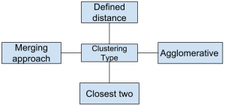

- Which of the following clustering type has characteristic shown in the below figure ?
- a)Partitional
b)Hierarchical
c)NaiveBayes
d)NoneoftheMentioned
View Answer
- Answer: b
Explanation: Hierarchical clustering groups data over a variety of scales by creating a cluster tree or dendrogram.

STATISTICAL INFERENCE

POPULATIONS, SAMPLES, ESTIMATES AND REPEATED SAMPLING
Statistical inference is the use of probability theory to make inferences about a population from sample data.
Suppose we want to estimate the characteristics of a population such as the average weight of all 30 year old women in Australia, or the percentage of voters in N.S.W. who think the Government is doing a good job to control inflation.
In practice we cannot obtain data from every member of the population. Instead, we obtain data from a sample and use the results to make inferences about the population.
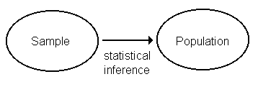

Definitions
Population - collection of all subjects or objects of interest (not necessarily people)
Sample - subset of the population used to make inferences about the characteristics of the population
Population parameter - numerical characteristic of a population, a fixed and usually unknown quantity.

five number summary
• in statistics, a summary of the distribution of a data set,
i.e. minimum value, lower (1st) quartile, median (middle value),
upper (3rd) quartile and the maximum value.
• often represented with a box plot.
EXAMPLES:
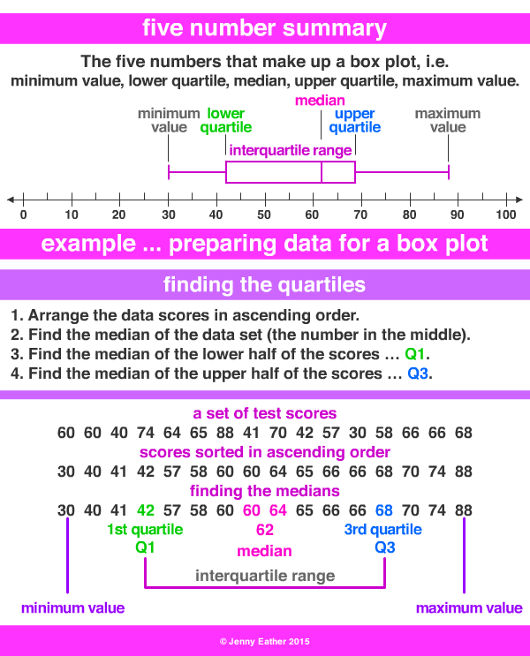

This set of Data Science Multiple Choice Questions & Answers (MCQs) focuses on “Exploratory Graphs”.
1. Which of the following graphs has properties in the below figure ?
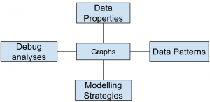
a) Exploratory
b) Inferential
c) Causal
d) None of the Mentioned
View Answer
Answer: a
Explanation: Making plots of the data reveals various interesting features.
2. Which of the following dimension type graph is shown in the below figure ?
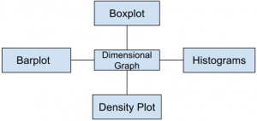
a) one-dimensional
b) two-dimensional
c) three-dimensional
d) none of the Mentioned
View Answer
Answer: b
Explanation: A two-dimensional graph is a set of points in two-dimensional space.
3. Which of the following gave rise to need of graphs in data analysis ?
a) Data visualization
b) Communicating results
c) Decision making
d) All of the Mentioned
View Answer
Answer: d
Explanation: A picture can tell better story than data.
4. Which of the following is characteristic of exploratory graph ?
a) Made Slowly
b) Axes are not cleaned up
c) Color is used for personal information
d) All of the Mentioned
View Answer
Answer: c
Explanation: A large number of exploratory graphs are made.
5. Point out the correct statement:
a) coplots are one dimensional data graph
b) Exploratory graphs are made quickly
c) Exploratory graphs are made relatively less in number
d) All of the Mentioned
View Answer
Answer: a
Explanation: coplot is used for two dimensional representation.
6. Which of the following graph can be used for simple summarization of data ?
a) Scatterplot
b) Overlaying
c) Barplot
d) All of the Mentioned
View Answer
Answer: c
Explanation: A bar chart or bar graph is a chart that presents Grouped data with rectangular bars with lengths proportional to the values that they represent.
7. Color and shape are used to add dimensions to graph data.
a) True
b) False
View Answer
Answer: a
Explanation: Graphs are commonly used by print and electronic media.
8. Which of the following information is not given by five-number summary ?
a) Mean
b) Median
c) Mode
d) All of the mentioned
View Answer
Answer: c
Explanation: The mode is the value that appears most often in a set of data.
9. Which of the following is also referred to as overlayed 1D plot ?
a) lattice
b) barplot
c) gplot
d) all of the Mentioned
View Answer
Answer: a
Explanation: lattice is an add-on package that implements Trellis graphics.
10. Spinning plots can be used for two dimensional data.
a) True
b) False
View Answer
Answer: a
Explanation: There are many ways to create 3D spinning plot as well

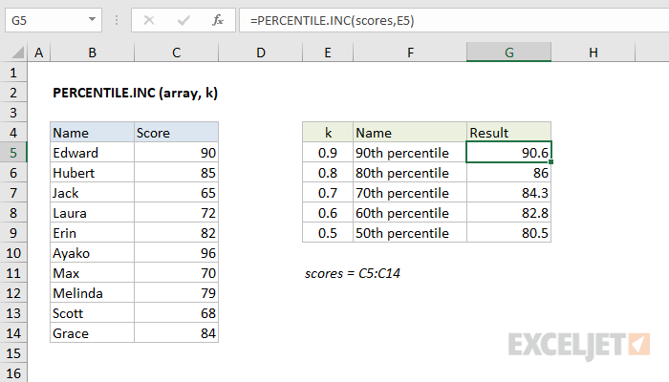

A cartogram is a type of graphic that depicts attributes of geographic objects as the object's area. Because a cartogram does not depict geographic space, but rather changes the size of objects depending on a certain attribute, a cartogram is not a true map.

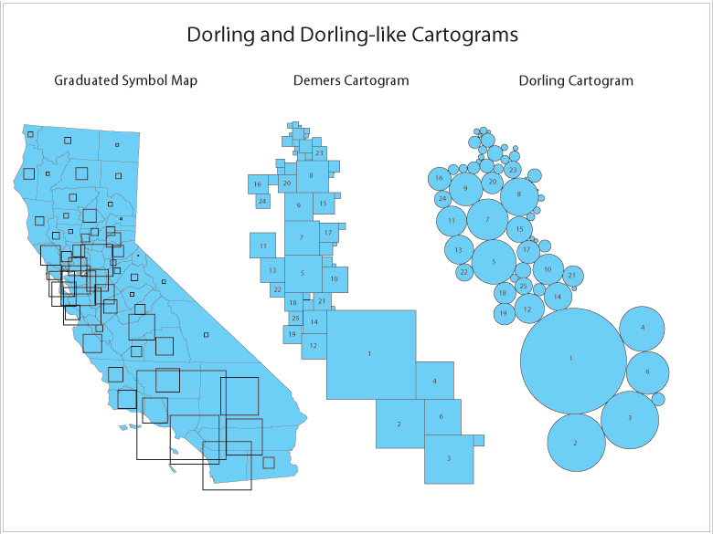

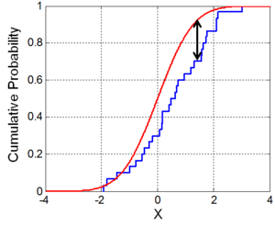
Illustration of the Kolmogorov–Smirnov statistic. Red line is CDF, blue line is an ECDF, and the black arrow is the K–S statistic.
In statistics, the Kolmogorov–Smirnov test (K–S test or KS test) is a nonparametric test of the equality of continuous, one-dimensional probability distributions that can be used to compare a sample with a reference probability distribution (one-sample K–S test), or to compare two samples (two-sample K–S test). It is named after Andrey Kolmogorov and Nikolai Smirnov.
The Kolmogorov–Smirnov statistic quantifies a distance between the empirical distribution function of the sample and the cumulative distribution function of the reference distribution, or between the empirical distribution functions of two samples. The null distribution of this statistic is calculated under the null hypothesis that the sample is drawn from the reference distribution (in the one-sample case) or that the samples are drawn from the same distribution (in the two-sample case). In each case, the distributions considered under the null hypothesis are continuous distributions but are otherwise unrestricted.

(Empirical distribution can be said to be theoretical distribution.)

Logistic Function
Logistic regression is named for the function used at the core of the method, the logistic function.
The logistic function, also called the sigmoid function was developed by statisticians to describe properties of population growth in ecology, rising quickly and maxing out at the carrying capacity of the environment. It’s an S-shaped curve that can take any real-valued number and map it into a value between 0 and 1, but never exactly at those limits.
1 / (1 + e^-value)
Where e is the base of the natural logarithms (Euler’s number or the EXP() function in your spreadsheet) and value is the actual numerical value that you want to transform. Below is a plot of the numbers between -5 and 5 transformed into the range 0 and 1 using the logistic function.
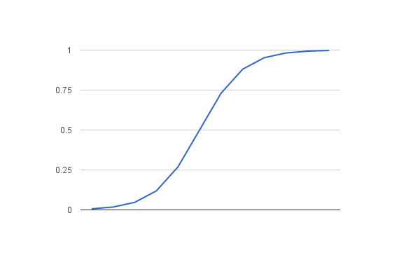
Logistic Function

Let’s start by considering a simple association between two dichotomous variables (a 2 x 2 crosstabulation) drawing on the LSYPE dataset. The outcome we are interested in is whether students aspire to continue in Full-time education (FTE) after the age of 16 (the current age at which students in England can choose to leave FTE). We are interested in whether this outcome varies between boys and girls. We can present this as a simple crosstabulation (Figure 4.2.1).
Figure 4.2.1: Aspiration to continue in full time education (FTE) after the age of 16 by gender: Cell counts and percentages
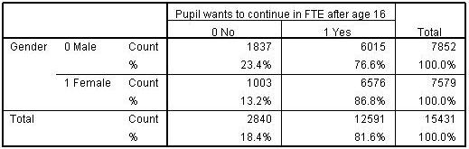
We have coded not aspiring to continue in FTE after age 16 as 0 and aspiring to do so as 1. Although it is possible to code the variable with any values, employing the values 0 and 1 has advantages. The mean of the variable will equal the proportion of cases with the value 1 and can therefore be interpreted as a probability. Thus we can see that the percentage of all students who aspire to continue in FTE after age 16 is 81.6%. This is equivalent to saying that the probability of aspiring to continue in FTE in our sample is 0.816.

Odds and odds ratios
However another way of thinking of this is in terms of the odds. Odds express the likelihood of an event occurring relative to the likelihood of an event not occurring. In our sample of 15,431 students, 12,591 aspire to continue in FTE while 2,840 do not aspire, so the odds of aspiring are 12591/2840 = 4.43:1 (this means the ratio is 4.43 to 1, but we conventionally do not explicitly include the :1 as this is implied by the odds). The odds tell us that if we choose a student at random from the sample they are 4.43 times more likely to aspire to continue in FTE than not to aspire to continue in FTE.
We don’t actually have to calculate the odds directly from the numbers of students if we know the proportion for whom the event occurs, since the odds of the event occurring can be gained directly from this proportion by the formula (Where p is the probability of the event occurring.):
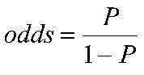
Thus the odds in our example are:
Odds= [p/(1-p)] = .816 / (1-.816 )= .816 /.184 = 4.43.
The above are the unconditional odds, i.e. the odds in the sample as a whole. However odds become really useful when we are interested in how some other variable might affect our outcome. We consider here what the odds of aspiring to remain in FTE are separately for boys and girls, i.e. conditional on gender. We have seen the odds of the event can be gained directly from the proportion by the formula odds=p/(1-p).
So for boys the odds of aspiring to continue in FTE = .766/(1-.766)= 3.27
While for girls the odds of aspiring to continue in FTE = .868/(1-.868)= 6.56.
These are the conditional odds, i.e. the odds depending on the condition of gender, either boy or girl.
We can see the odds of girls aspiring to continue in FTE are higher than for boys. We can in fact directly compare the odds for boys and the odds for girls by dividing one by the other to give the Odds Ratio (OR). If the odds were the same for boys and for girls then we would have an odds ratio of 1. If however the odds differ then the OR will depart from 1. In our example the odds for girls are 6.53 and the odds for boys are 3.27 so the OR= 6.56 / 3.27 = 2.002, or roughly 2:1. This says that girls are twice as likely as boys to aspire to continue in FTE.
Note that the way odd-ratios are expressed depends on the baseline or comparison category. For gender we have coded boys=0 and girls =1, so the boys are our natural base group. However if we had taken girls as the base category, then the odds ratio would be 3.27 / 6.56= 0.50:1. This implies that boys are half as likely to aspire to continue in FTE as girls. You will note that saying “Girls are twice as likely to aspire as boys” is actually identical to saying “boys are half as likely to aspire as girls”. Both figures say the same thing but just differ in terms of the base.
Odds Ratios from 0 to just below 1 indicate the event is less likely to happen in the comparison than in the base group, odds ratios of 1 indicate the event is exactly as likely to occur in the two groups, while odds ratios from just above 1 to infinity indicate the event is more likely to happen in the comparator than in the base group. Extension D provides a table that shows the equivalence between ORs in the range 0 to 1 with those in the range 1 to infinity.

In economics and cost accounting, total cost (TC) describes the total economic cost of production and is made up of variable costs, which vary according to the quantity of a good produced and include inputs such as labor and raw materials, plus fixed costs, which are independent of the quantity of a good produced and include inputs (capital) that cannot be varied in the short term, such as buildings and machinery.

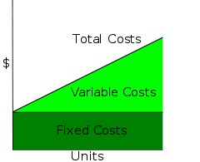

Stats: One-Way ANOVA

A One-Way Analysis of Variance is a way to test the equality of three or more means at one time by using variances.

Assumptions
- The populations from which the samples were obtained must be normally or approximately normally distributed.
- The samples must be independent.
- The variances of the populations must be equal.

Hypotheses
The null hypothesis will be that all population means are equal, the alternative hypothesis is that at least one mean is different.
In the following, lower case letters apply to the individual samples and capital letters apply to the entire set collectively. That is, n is one of many sample sizes, but N is the total sample size.

Grand Mean
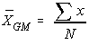
The grand mean of a set of samples is the total of all the data values divided by the total sample size. This requires that you have all of the sample data available to you, which is usually the case, but not always. It turns out that all that is necessary to find perform a one-way analysis of variance are the number of samples, the sample means, the sample variances, and the sample sizes.
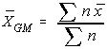
Another way to find the grand mean is to find the weighted average of the sample means. The weight applied is the sample size.

Total Variation
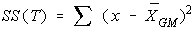
The total variation (not variance) is comprised the sum of the squares of the differences of each mean with the grand mean.
There is the between group variation and the within group variation. The whole idea behind the analysis of variance is to compare the ratio of between group variance to within group variance. If the variance caused by the interaction between the samples is much larger when compared to the variance that appears within each group, then it is because the means aren't the same.

Between Group Variation
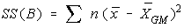
The variation due to the interaction between the samples is denoted SS(B) for Sum of Squares Between groups. If the sample means are close to each other (and therefore the Grand Mean) this will be small. There are k samples involved with one data value for each sample (the sample mean), so there are k-1 degrees of freedom.
The variance due to the interaction between the samples is denoted MS(B) for Mean Square Between groups. This is the between group variation divided by its degrees of freedom. It is also denoted by .

Within Group Variation
The variation due to differences within individual samples, denoted SS(W) for Sum of Squares Within groups. Each sample is considered independently, no interaction between samples is involved. The degrees of freedom is equal to the sum of the individual degrees of freedom for each sample. Since each sample has degrees of freedom equal to one less than their sample sizes, and there are k samples, the total degrees of freedom is k less than the total sample size: df = N - k.
The variance due to the differences within individual samples is denoted MS(W) for Mean Square Within groups. This is the within group variation divided by its degrees of freedom. It is also denoted by . It is the weighted average of the variances (weighted with the degrees of freedom).

F test statistic
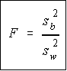
Recall that a F variable is the ratio of two independent chi-square variables divided by their respective degrees of freedom. Also recall that the F test statistic is the ratio of two sample variances, well, it turns out that's exactly what we have here. The F test statistic is found by dividing the between group variance by the within group variance. The degrees of freedom for the numerator are the degrees of freedom for the between group (k-1) and the degrees of freedom for the denominator are the degrees of freedom for the within group (N-k).

Summary Table
All of this sounds like a lot to remember, and it is. However, there is a table which makes things really nice.
 | SS | df | MS | F
Between | SS(B) | k-1 | SS(B)  -----------  k-1 | MS(B)  --------------  MS(W)
Within | SS(W) | N-k | SS(W)  -----------  N-k | .
Total | SS(W) + SS(B) | N-1 | . | .
Notice that each Mean Square is just the Sum of Squares divided by its degrees of freedom, and the F value is the ratio of the mean squares. Do not put the largest variance in the numerator, always divide the between variance by the within variance. If the between variance is smaller than the within variance, then the means are really close to each other and you will fail to reject the claim that they are all equal. The degrees of freedom of the F-test are in the same order they appear in the table (nifty, eh?).

